**Legend**

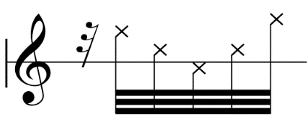**Notes**

= button clicks, position on stave indicate relative pitch (little change in the sounding pitch, it is the gesture that is desired)

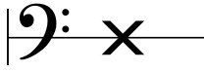

= strike body of the instrument with the knuckle

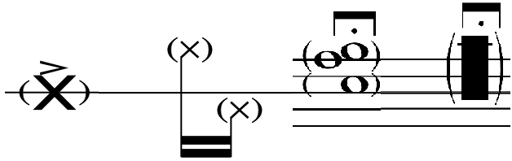

= brackets indicate silently miming the specified note/technique (can be applied to any)

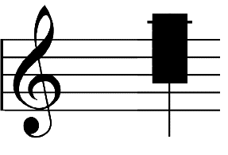**Cluster**

= cluster (with palm or forearm depending on size)

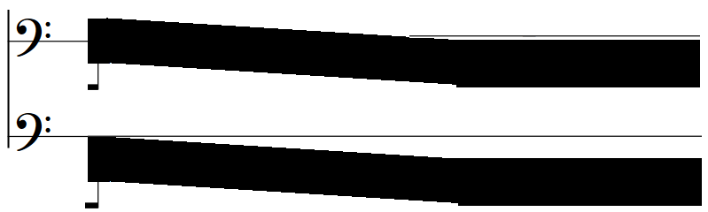

= glissando cluster (with palm or forearm depending on size)

**Other Signs**

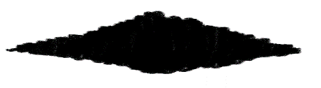

= air sound from bellow, with no registers

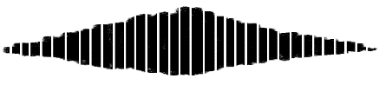

= processed air sound with gaps (Tape)

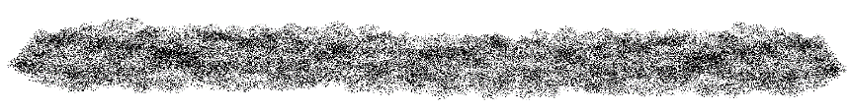

= processed bass resonance (Tape)